Data Profiling and Progress Monitoring Application with Data Analytics Technique for Archdiocesan Nourishment Center

Michael Jason A. Torres
BS in Information Technology
University of Mindanao
09228081290, Philippines 8000
michaeljason_torres@umindanao.edu.ph
Ivy V. Ybiernas
Fe B. Yara
Master of Science in Information Science
University of Mindanao
09063260253, Philippines 8000
fe_yara@umindanao.edu.ph

BS in Information Technology
University of Mindanao
09096576547, Philippines 8000
ivyybiernas@outlook.com
Lady Sheen A. Gilbang
BS in Information Technology
University of Mindanao
09103572769, Philippines 8000
lsgilbang@gmail.com

Categories and Subject Descriptors
[Stand-alone Application] Data Analytics Technique
General Terms
The general terms used are: Data Analytics and Decision Support System
Keywords
Data Profiling, Progress Monitoring and Archdiocesan Nourishment Center (ANC)

INTRODUCTION

Project Context

Because of the existence of technology, Organizations with many transactions use automated system. Upgrading into automated system helps not only the synchronization of data but also the accuracy. Systems are created to address problems in some organization. Having these systems helped organizations for an easier daily transaction.
Archdiocesan Nourishment Center(ANC) located at Pag-asa St. Davao City is a non-profit charitable organization for children handled by nuns and priests. This organization is supported by volunteers and is given donations by donors. Every day they welcome children who visit the center to have meal. A nutritionist helps them monitor the health progress of each child who visits them, every month they conduct check-ups to see if the child has improved their health or not, and house visitations quarterly to monitor their family.
The problem is ANC has difficulty in monitoring the progress of each child and come up with possible diagnosis based on their current results examined by their medical staffs. They are also having difficulties in analyzing medical and nutritional status of children, difficulties in determining and comparing statistic report and lastly difficulties in determining children that requires the most medical attention and currently in critical alert status. They currently don’t have the technology that would help them for such problems.
Data analytics is a helpful platform that would leverage conventional and untraditional data sources. Since the problems of the organization require comparison and progression of data because they need to monitor the children’s status, data analytics is a secure platform and informed tool selection that would give accurate analysis to the children’s nutritional status and progress. How this is done is through a data integration and visualization which combine and dynamically present data to understand trends and relationship. The type of data analytics the researchers will make is a quantitative data analysis. It would provide a numerical value that would compare and measure statistically. This analysis would compare the historical data of the children and the current data with the use of analysis. With the help of data analytics, there is a quality in the data assessed since those are valid robust supporting data.
Therefore, data analytics technologies and techniques will help them because it is widely used in commercial industries to enable organizations to make more-informed decisions. The data that are analyzed are consist of both previous and current information that has been processed for real-time analytics.

Purpose and Description

The main purpose of the proposed study is to provide a computerized data profiling and progress monitoring application with data analytics technique to easily track the child’s nutritional progress, analyze their medical and nutritional status based on the data profiling provided.

Data Profiling and Progress Monitoring Application is an application which will help ANC in terms of handling the nutritional status of each child under their program. Basic information gathered from Child Information Sheet, Household Information Sheet and Medical Information will be inputted for Data Profiling. All gathered data will be stored in centralized database and will be used for data analysis. With the incorporation of Data Analytics Technique in this application, not only this application will help them in terms of monitoring child’s nutritional status but it will also help them analyze medical status such as the increase and decrease of BMI and possible causes of nutritional problems. It will also give notifications that will help them determine which children need immediate medical attention. Lastly this application will also generate and provide statistic reports they require.

Objectives

GENEREAL OBJECTIVES
The main goal of the researchers is to develop a Data Profiling and Progress Monitoring Application with Data Analytics Technique for Archdiocesan Nourishment Center.

SPECIFIC OBJECTIVES
To accomplish the general objective, the group aim to develop an application specifically to:

Analyze the medical and nutritional status of the Archdiocesan Nourishment Center (ANC) children using Data Analytics Techniques.

Generate recommendations for possible treatment and proper nutritional diet using Decision Support System.

Generate statistical report in graphical representation using Highcharts Interactive JavaScript charts.

Notify the medical staffs regarding children that requires immediate medical attention, prioritization and medical schedules using JQUERY tool.

Scope and Limitation

The proposed application is a stand-alone application that will be used by Archdiocesan Nourishment Center. This application will allow them to create children profiles then monitor and analyze the nutritional status of each child with the help of data analytics technique and decision support system. Also, with the request of the company this application will have add-on features such as accounting and inventory system. This application will only focus on the monitoring of nutritional status of the children and not on the intensive medical aspects in determining the health status of each child.

REVIEW OF RELATED LITERATURE/ SYSTEMS

GEMINI: An Integrative Healthcare Analytics System

Healthcare systems around the world are facing the challenge of information overload in caring for patients in an affordable, safe and high-quality manner in a system with limited healthcare resources and increasing costs. The researchers developed a system for integrated healthcare analytics called GEMINI. [1]

In relation to the researchers’ study, GEMINI extracts data of each patient from various data sources and stores them as information in a patient profile. This system has components such as Patient Profiling, Healthcare Analytics and Supporting Platforms which is similar to the researchers’ study which has components such as Data Profiling, Data Analytics and Decision Support System. GEMINI’s Supporting Platforms is where Patient Profiling and Healthcare Analytics gets support such as giving healthcare related suggestions. However, the researchers’ study is not limited in only giving suggestions it also gives notification for children that needs immediate medical attention.

Toward a Big Data Healthcare Analytics System: A Mathematical Modeling Perspective

Handling big data with the use of medical devices in healthcare department needs to be intensive and accurate especially in Intensive Care Units (ICU) that manage high speed physiological data. The importance of properly managing these data can help progress health conditions and also lessen the death and disability rates of those patients who have critical conditions. One of the advantages of using big data associating ICUs is to create or form cloud-based health analytics which analyzes disease prevention and earlier onset condition detection. In the area of Neonatal Intensive care units, the Artemis project is on board to achieve the cloud-based health analytics. [2]
Neonatal Intensive care units provide intensive monitoring for premature and ill term infants. Usually, premature birth is a birth before 37 weeks gestational age and it is one of the most common but important pregnancy health problems in the world, but in NICU, they have premature infants as young as 23 weeks gestation. [3]
In relation to the researchers’ study, this research about “Toward a Big Data Healthcare Analytics System: A Mathematical Modeling Perspective” was conducted to create a system that thru data gathered, analytics will be implemented. Quantitative data analysis will be used, that thru numerical data and statistics results will be generated. However, Artemis project used cloud framework while the proposed system is a stand-alone application. It also focuses on infants’ health which is dissimilar to the researchers’ study which focuses on the nutritional health of children ages from 3 to 9.

Data Processing System (DPS) software with experimental design, statistical analysis and data mining developed for use in entomological research

A comprehensive but simple-to-use software package called DPS (Data Processing System) has been developed to execute a range of standard numerical analyses and operations used in experimental design, statistics and data mining. [4]

In relation to the researchers’ study, DPS uses quantitative data analysis. However, the DPS focuses in entomological and biological functions dissimilar to the researchers’ study which gathers nutritional data of children to implement analytics technique.

2.4 A platform for secure monitoring and sharing of generic health data in the Cloud

The growing need for the remote caring of patients at home combined with the ever-increasing popularity of mobile devices due to their ubiquitous nature has resulted in many apps being developed to enable mobile telecare. The Cloud, in combination with mobile technologies has enabled doctors to conveniently monitor and assess patient’s health while the patient is at the comfort of their own home. [5]

In relation to the researchers’ study, the application “A Platform for secure monitoring and sharing of generic health data in cloud” was developed to monitor and assess patients’ health. However, the proposed system enables mobile telecare thru the combination of smartphones, Bluetooth and cloud. With the use of smartphones and access in Bluetooth and cloud it enables the monitoring of patient’s health anywhere. While the researchers’ study will create a stand-alone application with the use of data analytics and decision support system to monitor nutritional progress of children.

Leveraging the capabilities of service-oriented decision support systems: Putting analytics and big data in cloud

Using service-oriented decision support systems (DSS in cloud) is one of the major trends for many organizations in hopes of becoming more agile.
This article discussed the requirements for service oriented DSS such as Accuracy, Security, Governance, Compliance, Collaborative, Intra and inter- organizational synchronous, agile accommodation, adaptive, reuse and integration, virtual and service oriented. They proposed a conceptual framework for DSS in cloud. SODSS has four major components such as Operational System, Data Warehousing, Online Analytic Processing and End-user components. Each component is essential in completing the whole concept of SODSS. [6]

In relation to the researchers’ study, this article discussed that it is helpful to incorporate decision support system with analytics, thru this it can help by giving recommendations for possible treatments etc. However, this article discussed a proposed cloud framework for DSS which not present in the researchers’ study. The researchers’ study focuses on creating a stand-alone application incorporated with data analytics technique.

BRINGING HEALTHCARE ANALYTICS TO WHERE BIG DATA RESIDES USING A DISTRIBUTED QUERY SYSTEM.

It is generally difficult to move Big Data and put it into a central location. Ordinarily this would prevent one from querying several repositories of patient-oriented Big Data as a unified whole. However, we have been developing a distributed query system where the Big Data is indexed in the location where it typically lies, and surrounding each index we have created software based upon the Informatics for Integrating Biology and the Bedside (i2b2) project to access the index used to organize the Big Data. We have applied this to allow us to query Genomics, Imaging, and Textual data to be queried along with traditional coded Healthcare data. [7]

In relation to the researchers’ study, the research “Bringing Healthcare Analytics to where Big Data Resides Using a Distributed Query System” was conducted to create an API or Application Programming Interface which allows data analysis in big data resources in healthcare. However, this research also developed a distributed query system which is not present in the researchers’ study. Nonetheless, the researchers’ study focuses on creating an application for profiling and progress monitoring using data analytics technique incorporated with decision support system.

Big data analytics in healthcare: promise and potential

Big data analytics and application in healthcare is now at the level where it is starting to exist in development. In healthcare industry, large amounts of data have been generated. While most data were stored in hard copy form, the current trend is the computerization of large amount of data. Big data in healthcare is overwhelming because of its dimensions that needs to be managed. [8]

In relation to the researchers’ study about data analytics, this article also states that thru understanding patterns and data trends, data analytics can improve healthcare services. However, this article only focused in data analytics dissimilar to the researchers’ study which incorporated decision support system to data analytics by having data profiling and progress monitoring application.

Big data analytics for healthcare

There are a lot of various healthcare organizations and it has a large amount of different medical data (pharmaceuticals, providers and payers). Those data are converted into a resource needed for insights for improving healthcare delivery. The enormity and complexity of these datasets present great challenges in analyses and subsequent applications to a practical clinical environment. [9]
In relation to the researchers’ study, this article tackled about data/healthcare analytics applications and tutorials where they introduce the features and related mining challenges on dealing with medical data. The researchers in this article performed surveys to discuss with the audiences the key problems and trends in healthcare analytics research, with different applications ranging from clinical text mining, predictive modelling, survival analytics, patient similarity, genetic data analysis, and public health. However, this article tackled different applications but did not mention any supporting platforms dissimilar to the researchers’ study which introduces Decision Support System that will be incorporated with data analytics to generate more accurate results.

Distributed data networks: a blueprint for Big Data sharing and healthcare analytics

There is a growing body of literature on the use of non-hypothesis-driven analytic approaches to identify patterns in the burgeoning volume of healthcare and clinical data. These approaches have recently been used in a number of different types of patient health studies to date, for example, to identify high-cost patients, aid in the reconciliation of potentially erroneous entries in medication lists in patients’ medical records, and identify patients at high risk for developing specific clinical conditions. [10]
In this article, the researcher discussed that by focusing on the six pillars of analytic infrastructure: consistency, reusability, flexibility, scalability, transparency and reproducibility, distributed data network has made to the healthcare analytics community. Lastly, it introduces the machine learning algorithm development as an evolving analytic framework to further advance the portfolio of population health analytics [11].

In relation to the researchers’ study, this article discussed that thru identifying patterns healthcare and data analysis can be implemented and thru data analysis patients with high risk of developing specific condition will be identified which is similar to the researchers’ study that thru data analytics it will determine children that requires immediate medical attention. However, this article only focused on data analytics and did not introduced any platform dissimilar to the researchers’ study which incorporated data analytics to decision support system in an application which is proposed and intended to run in any platform but mostly be used in windows platform by the organization.

Big Data and Analytics in Healthcare

This article discussed the Methods of Information in Medicine on “Big Data and Analytics in Healthcare”. A large amount of date being generated in the healthcare industry is growing. this data is being used to improve health outcomes and lower costs. Challenges are present in processing and analyzing given that there is big amount of data in healthcare. This article focused on giving information and method that would address those problems. More specifically, efficient methods of processing large clinical data to predictive models that could generate better predictions from healthcare data are presented. [12]

In relation to the researchers’ study, this article discussed that thru data analytics healthcare services can be improved. However, this article focused specifically in data analytics and predictive models dissimilar to the researchers’ study which incorporated data analytics and DSS in an application of data profiling and progress monitoring of nutritional status.

TECHNICAL BACKGROUND

In this chapter, the researchers will discuss the development process of data profiling and progress monitoring application with data analytics technique and decision support system. The current and proposed system will also be discussed.

IPO1: Conceptual Framework

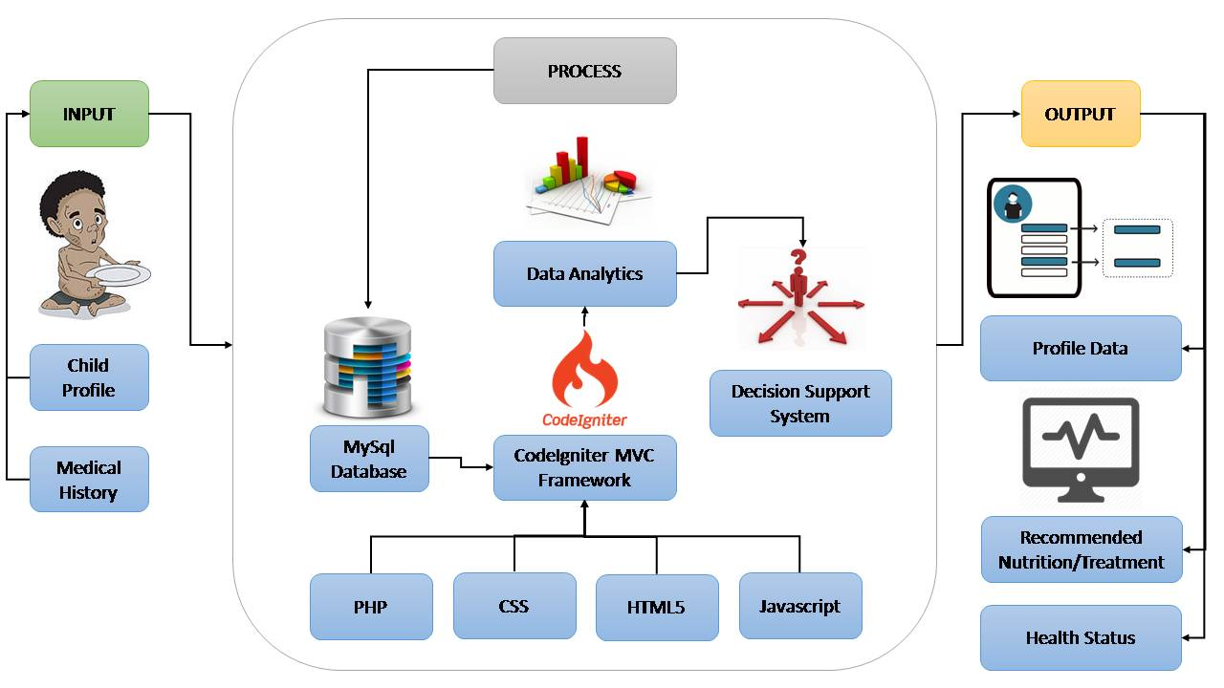

Figure 1: Conceptual Framework

The first step of the proposed system is, the user will input the child’s basic information such as Name, date of birth, place of birth, age, sex, religion, initial weight, initial height, disability (if any), contact number, school the child is enrolled, home address, grade level, etc. Inputting family member’s information is also included in the system such as name, sex, relation to the child, age, marital status, educational attainment, occupation and income. Medical history of the child is a factor in data analytics as well as the weight and height so it should be properly inputted in the system for analysis. After all the information are being recorded, the next step is the system will process the records and will be stored in the database MYSQL. Then, the CodeIgniter MVC Framework which is a tool for Data Analytics (which will be discussed in IPO2) that is composed of programming languages such as PHP, CSS, HTML5, JavaScript will access the Database then it would generate a Decision Support System (which will be discussed in IPO2). The system will then output a profile data of the child with the health status and recommended Nutrition/Treatment.

IPO2: Data Analytics and Decision Support System Process

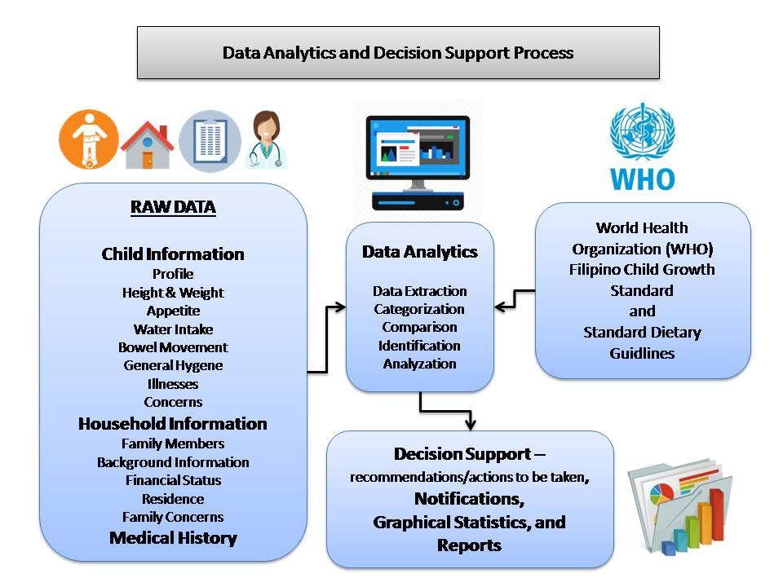
Figure 2: Data Analytics and Decision Support System

Figure 2 shows the process of data analytics and decision support system.

By definition, Data analytics refers to qualitative and quantitative techniques and processes used to enhance productivity and business gain. Data is extracted and categorized to identify and analyse behavioural data and patterns, and techniques vary according to organizational requirements. [13] While Decision Support also known as DSS is a computer program application that analyzes business data and presents it so that users can make business decisions more easily. It is an "informational application" (to distinguish it from an "operational application" that collects the data in the course of normal business operation). [14]
Based from the World Health Organization (WHO) Filipino Child Growth Standards (see tables 1 and 2 for samples) and Standard Dietary Guidelines as baseline and from the raw data gathered such as Child Information, Household Information and Medical History. Data analytics techniques such as Regression Analysis and Decision Tree Analysis will be utilized, and Data Analytics will be applied by Data Extraction, Categorization, Comparison, Identification and Analyzation.
Since Regression Analysis involves how an independent variable affects the dependent variable, this technique will show how dependent variable changes when independent variable varied. For example, with data such as age, height and weight, the age is the independent variable while height and weight are dependent to age, since age is a continuous quantitative data, as age increases the required height and weight also increases.
Regression analysis is also a way of mathematically sorting out which of those variables does indeed have an impact. It answers the questions: Which factors matter most? Which can we ignore? How do those factors interact with each other? And, perhaps most importantly, how certain are we about all of these factors? [15]
To further explain on how does Regression Analysis works, the researchers have provided an example process based on the ANC‘s contextual statistical data.
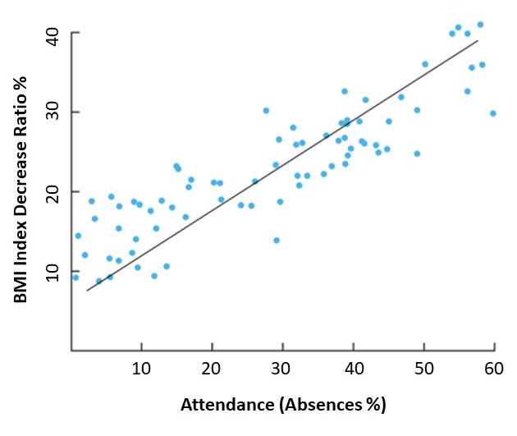

Figure 3: Regression Analysis Example

The y-axis is the amount of BMI index decrease ratio in percentage (the dependent variable) and the x-axis is the attendance (absences percentage). Each blue dot represents one month’s data—how much absences and falling nutritional status percentage they had the same month. Then come up with conclusion regarding the effectiveness of their current programs
Based on the graphical data shown, the amount of decrease in BMI index corresponds to the amount of absences committed during that month. The higher the BMI decrease ratio, the higher the absences. Therefore, absences greatly affect the nutritional status of the beneficiaries. It gives them the idea to further assess and enhance their programs and activities each month or conduct more home visitations.
Another technique the researchers will use is the Decision Tree Analysis also known as Classification Tree Analysis. By definition, a decision tree as a predictive model is to go from observations about an item (represented in the branches) to conclusions about the item's target value (represented in the leaves). It is one of the predictive modeling approaches used in statistics, data mining and machine learning. [16]
The Decision Tree Analysis will help as a decision support. For example, a child has a failing nutritional status and considered as severely wasted (acute malnourished). The system will find out what are the possible causes based on various factors leveled accordingly by their significance.

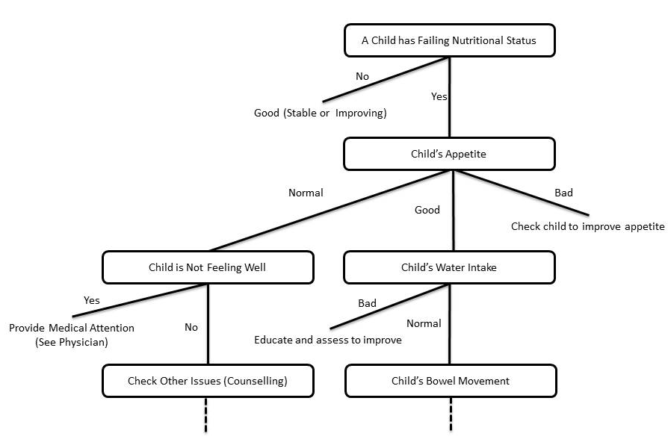

Figure 4: Decision Tree Analysis Example

According to ANC’s Nutritionists some factors of failing nutritional status are Illnesses, Appetite, Water Intake, Bowel Movement, General Hygiene, Behavior, Environment, etc. These factors are levelled accordingly by the system to provide a better overview on the problems that affects such issues and further assess the child’s nutritional status by gradually monitoring these problems along the way to its progression.
By extracting data from the CIS, HIS and Medical History of the children, it will identify, compare and analyze the data whether it belongs to a specific category or not. Another example is when data are extracted such as age, height and weight. It will be used to calculate and identify the Body Mass Index (BMI) of the child. After getting the BMI index value, it will be compared with the growth standard and will be analysed whether it belongs to these categories: N (Normal), UW (Underweight), St (Stunted), SS (Severely Stunted), SU (Severely Underweight), W (wasted), etc.
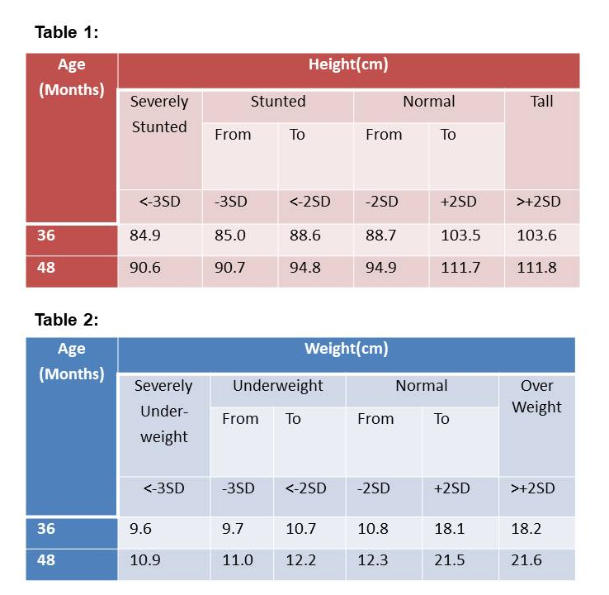
Figure 5: Height and Weight Status Tables
Since Decision Tree Analysis is used as decision support, after the analysis of extracted data, this technique will help give recommendations/suggestions and remarks for each category. For example, if a child has a status below normal the system will generate recommendations/suggestions like what vitamins to take, possible treatments, proper nutritional diet, and how long the child should be monitored. While for normal category, some remarks will be given for logs and future custom analysis.
Lastly, system notifications, graphical statistics and reports will also be generated to further represent the system’s gathered information and analysis.

IPO3: System’s Infrastructure

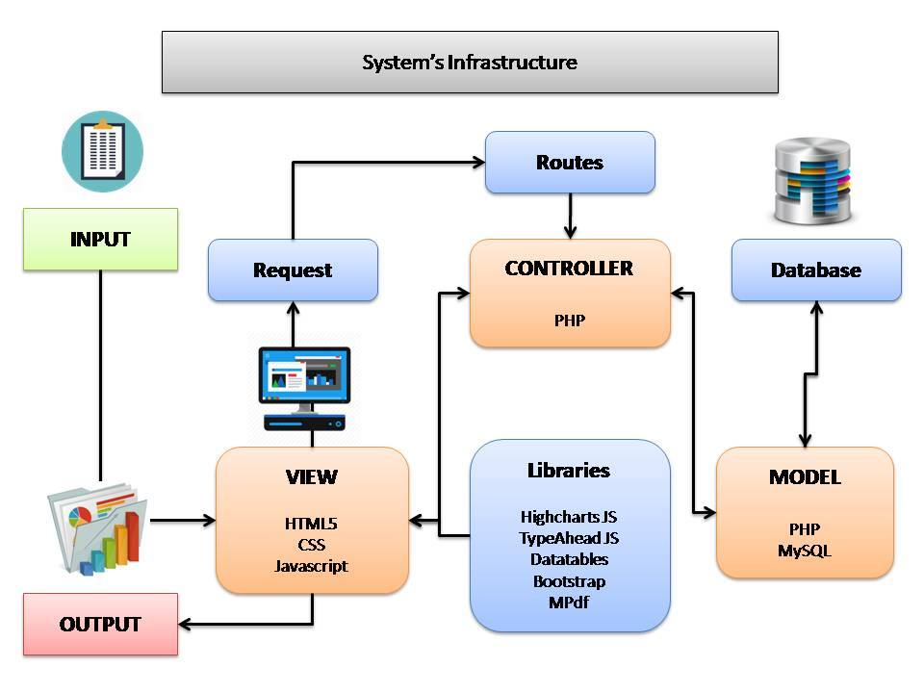

Figure 6: System’s Infrastructure

Figure 3 shows the process of the system’s infrastructure.

The system’s infrastructure shows that the user will input the data to the view which is the graphical user interface (GUI) of the system. It is composed of various programming languages such as HTML5, CSS, and Javascript. HTML5 provides the structure of the web pages, CSS is for the designing part, and Javascript is for the client-side processing language that handles the client-side logic of the system. The system will then send a URL request to the routes upon every submission of a form. The routes will handle the routing of the system by sanitizing and providing an alias in every URL request. The controller will handle the request and provide server-side validations for every input. Both javascript and PHP will work hand in hand for the validations. Javascript is for the client side while PHP is for the server-side validation. The controller will then evaluate and process the input through PHP server-side processing language by calling methods in the model. The model is responsible for all the system’s database processes. It is the one that sends queries, combine sql statements, and sanitize database inputs and outputs to prevent sql injection problems. The model is connected to the MySQL database, which serve as the database storage of all the system’s data. The system request will then return a response in the form of an output. The model will send the generated output of the query to the controller then the controller will send it to the view. The view will access the library tools connected to the system such as Highchart JS for generating graphical representation of information, Typeahead JS for multi-functional selection box or combo box, Datatables for tables that are highly flexible, adds advanced interaction controls to HTML table, has sorting, paging and filtering abilities powered by Javascript. Bootstrap for design framework, and MPdf for generating PDF converted reports.

Current System

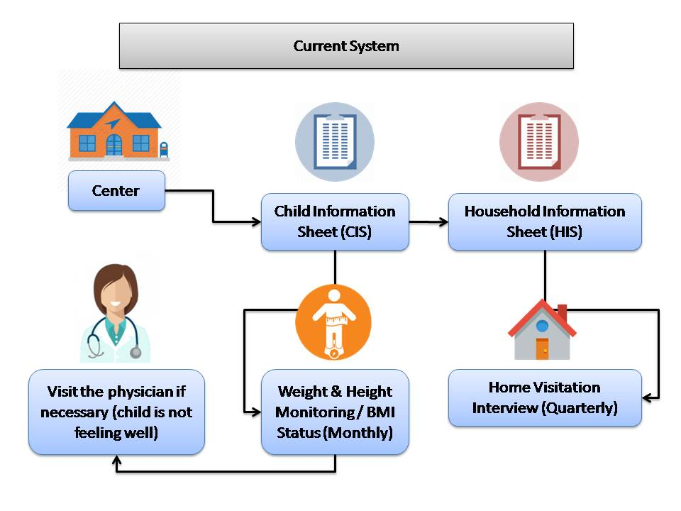

Figure 7: Current System

Figure 4 shows the current process in Data profiling of children of Archdiocesan Nourishment Center:

The first step is that children will visit the ANC, and children will enroll in their nutritional program, Information such as Name, Birthday, Place of birth, Age, Sex, Religion, Initial Weight, Initial Height, Disability (if any), Contact number, Home Address and Date of registration of the children will be written in their Child’s Information Sheet(CIS).
The next step is that ANC’s volunteers particularly social workers will visit the house of the child enrolled in their program to gather the household information, Information such as Ngalan sa Ulohan sa Pamilya (Head of the Family), Address, Mga Meyembro sa Pamilya (Members of the Family) and Date Interviewed will be Written in their Household Information Sheet(HIS). Then every quarter they will visit the household again to do Home Visitation Interview. Each quarter, they will gather and record information such as height, weight, appetite, water intake, bowel movement, general hygiene, date and time of the visit.

Lastly, monthly monitoring of height and weight of the child will be conducted to check BMI status. They can also visit the physician anytime if necessary, for example if the child is not feeling well.

Proposed System

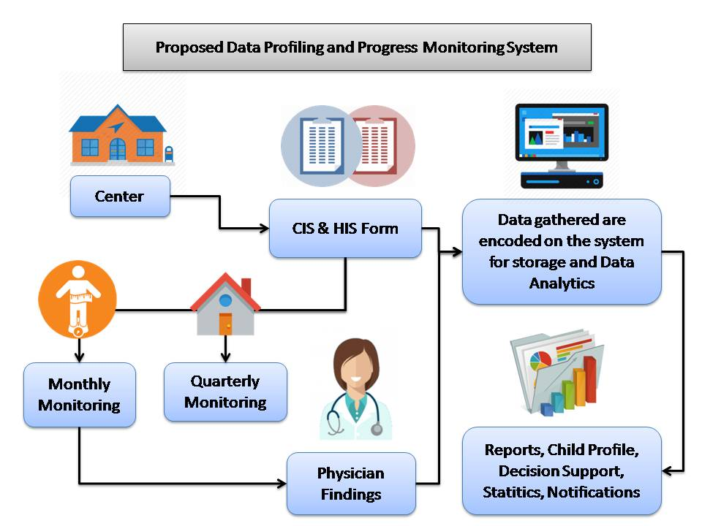
Figure 8: Proposed System

Figure 5 shows the proposed data profiling and progress monitoring application for Archdiocesan Nourishment Center:

The proposed system will help ANC in terms of data profiling and progress monitoring of each child under their program. Data gathered from the Child Information Sheet, Household Information Sheet, Monthly monitoring, Quarterly monitoring and Physician’s findings during check-ups will be encoded on the system for storage and Data Analytics. All data gathered will be stored in a centralized database. This proposed system will analyze the medical and nutritional status of the child, generate recommendations of possible treatments and proper nutritional diet, generate statistical reports in graphical representation, and will give notifications regarding the children that requires immediate medical attention, prioritization and medical schedules.

REFERENCES

- Ling, Z., Tran, Q., Fan, J., Koh, G., Nguyen T., Tan, C., Yip, J. and Zhang, M. (2014). National University Health System. National University of Singapore.
- Khazaei, H., McGregor, C., Eklund M., El-Khatib, K. and Thommandram, A. (2014). University of Ontario Institute of Technology Oshawa, Canada
- M. S. Kramer, R. W. Platt, H. Yang, K. S. Joseph, S. W. Wen, L. Morin, and R. H. Usher. (2014) Secular trends in preterm birth: A hospital-based cohort study
- Tang, Q. and Zhang, C. (2013). Institute of Insect Science, Zhejiang University, Hangzhou, China
- Thilakanathana, D., Chenb,Y. ,Nepal S., Calvoa, R. and Alemb L. (2013). The University of Australia
- Demirkhan, H. and Delen, D. (2013). The Milgard School of Business, University of Washington Tacoma, United States. Department of Management Science and Information Systems, Spears School of Business, Oklahoma State University, United States.
- Murphy, Shawn; Goodson, Alyssa; Mendis, Michael; Murphy, Marykate; Phillips, Lori; Yanbing Wang; Herrick, Christopher. (2016). IADIS International Journal on Computer Science & Information Systems
- Raghupathi, W., and Raghupathi, V. (2014). Raghupathi and Raghupathi Health Information Science and Systems. https://www.biomedcentral.com/track/pdf/10.1186/2047-2501-2-3?site=hissjournal.biomedcentral.com
- Sun, J., and Reddy, C. (2013). ACM DIGITAL LIBRARY. IBM TJ Watson Research Center, Yorktown Heights, NY, USA and Wayne State University, Detroit, MI, USA.
- Waljee, A.K., P.D.R. Higgins& A.G. Singal. (2014). A primer on predictive models. Clin. Transl. Gastroenterol.
- Popovic, J. (2016). Harvard Medical School/Harvard Pilgrim Health Care Institute, Boston, Massachusetts
- Tan, S., Gao, G. and Koch, S. (2016). Centre for Health Informatics, Department of Information Systems, National University of Singapore, Singapore; Center for Health Information and Decision Systems, University of Maryland, College Park, USA; Health Informatics Centre, Department of Learning, Informatics, Management and Ethics, Karolinska Institute, Stockholm, Sweden
- https://www.techopedia.com/definition/26418/data-analytics
- http://searchcio.techtarget.com/definition/decision-support-system
- https://hbr.org/2015/11/a-refresher-on-regression-analysis
- http://study.com/academy/lesson/what-is-a-decision-tree-examples-advantages-role-in-management.html

